Tri-County AOK Network Monthly Meeting Agenda
October 20, 2026 | 9-10:30 a.m.
The Tri-County All Our Kids Early Childhood Network provides equitable, accessible, quality, and comprehensive system for all children birth to five and their families. We believe that every child deserves to reach their full potential, and we are committed to ensuring that all children have the opportunity to thrive.
Attendance
Rachel Ledbetter- TCHD
Sam Marsh- AOK/TCHD
Shahnaz Jaleel- Carle/Trillium
Kristina Gillis- AOK/TCHD
Zoey Skinner- CHAIL
Dominica Rogers- CHOI
Christopher Heider- CHAIL
Tiffany Kerr- AOK/TCHD
Felicia Farden- Birth to Five IL
Molly Long- CFPA
Donna Ashley- TWHS
Carrissa Richmond- Brightpoint
Shalane Herrod- AOK/TCHD
Anna Hansard- Peoria ROE
Sarah Williams- TCHD
Courtney Long- Birth to Five IL
Kara Arbogast- TWHS
Erica Strunk- CFC #14
Trinity Wand- CYFS
Kami McClure- SAL CCC
Kari Clark- Birth to Five IL
Beth Beachy- TCHD
Jacqueline Blackburn- CHAIL
Kara Prohaska- Bright Futures
Amy Jackson- SAL/Home Child Care Network

Welcome & Icebreaker
- What has been your favorite Halloween costume over the years?
Today’s Meeting Focus – AOK Network, October Awareness & FY27 Workgroups
- AOK Network
  - Where do you fit in?
  - Who is missing? 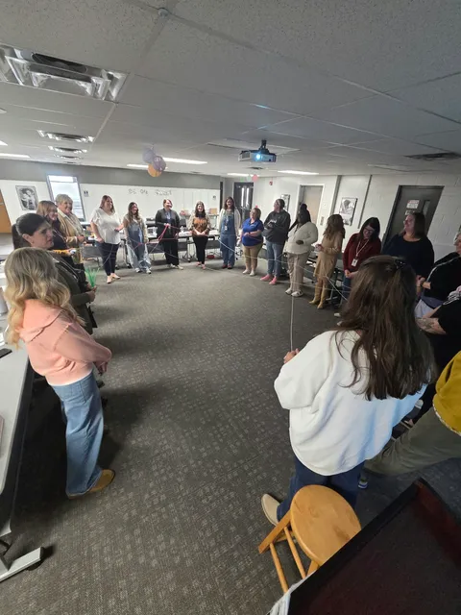
- Grief Presentation
-Reminders about self-care, “can’t pour from an empty cup”
- Safe Sleep Awareness Month
-ABC’s of Safe Sleep
- Domestic Violence Awareness Month
- Workgroups
  - Network Capacity
    - Resource Library
    - Parent Ambassador Recruitment
  - Information and Referral
    - IRIS Onboarding Procedures
      - Share out at the end of the meeting
  - Child and Family Outcomes
    - ASQ Screenings
    - Social-Emotional Development
AOK Updates
- AOK Facebook
  - Share events
  - Share information
- Resource Guide
  - Surveys – how did they hear about your services
- IRIS Informational Event
  - November 10 from 11 a.m.-3 p.m.
- Parents Helping Parents Event
-Tentative date TBD, hopefully secured in early Nov.
-Will be on a Saturday, possibly in April from 10-1ish.
-Amy from Home Childcare Network states there are non-traditional in-home providers in Tri-County available, including 3rd shift providers. Some providers have 18-hour licenses, weekend care, and holiday care. Amy states that people can contact the Home Child Care Network office in Peoria or Galesburg to find out about care near them. They have a list of all providers with current openings. They work with CCAP funding. Works closely with SAL CCC.
Parent Ambassadors
- September Events
  - Morton Pumpkin Festival
  - Tri-County Hunger Walk
- Looking for more PAs
  - Tazewell, Woodford, Peoria
Partner Events
- OSF Car-A-Van Schedule
  - Wednesday, October 15 from 9:30 a.m.-12 p.m. | Mosaic Christian Church
  - Thursday, October 22 from 9:30 a.m.-12 p.m. | Friendship House
  - Wednesday, October 28 from 9 a.m.-12 p.m. | Sophia’s Kitchen
- TCI Retreat: Community Strategies for Substance Use Prevention | October 22 from 11 a.m.-1 p.m. (registration by October 12)
- Home Visiting Summit 10/21 in Springfield
- Infant Toddler Pyramid Model | October 22 from 6:30-9 p.m.
- 32nd Annual Prevent Child Abuse Illinois Statewide Conference | October 22-23
- Extremism in Youth: The Rise of Nihilistic Violent Extremism | Thursday, October 22 from 4:30-6 p.m.
- Community Health Worker (CHW) Career & Workforce Connections | October 24 from 10 a.m.-12:30 p.m.
- Spoonful: Fundraiser to Benefit Sophia’s Kitchen | Sunday, October 25 from 10 a.m.- 2p.m.
- Preschool Social-Emotional Learning Series – Module 2 | October 27
- Seeing The Signs. Saving The Future: Stopping Nihilistic Violence Extremism Before Violence Occurs | October 28 from 12:30-4:30 p.m.
- PCA IL Webinar: The Effects of Domestic Violence on Children | October 29 from 10-11:30 a.m.
- Brain Aging Conference | Thursday, October 29 from 10 a.m.-3:30 p.m.
- Goodwill Hiring Event | October 30 from 9-11 a.m.
- GBC Autism Services Trunk-or-Treat | Saturday, October 31 from 12-3 p.m.
- Holding Hope Your Grief Your Pace | Monday, November 2 from 6-7 p.m.
- Harvest Your Health | Saturday, November 7 from 10 a.m.-2 p.m.
- OSF Peace Meal | Tuesday, November 24 and Tuesday, December 22
- Zumbini Happy Hour | December 4 from 10:30 a.m.-12 p.m.
- Community Resource Fair: For Young People Ages 13-25 | Saturday, February 20 from 11 a.m.-1 p.m.
Partner Groups/Announcements
- Hope Chest Updates – TCHD Referral
- FREE Air Purifier for Your Community Organization | Peoria City/County Health Department
  - Contact Rochelle Carter rcarter@peoriacounty.gov
- Goodwill GoodGuides, youth mentorship program
  - Contact Mehan Marin megan.marin@goodwillpeoria.org
- Crittenton Centers Anger Management: 4-weekly sessions | October 20, 27, November 3, 10 from 1-3 p.m. *must attend all sessions
  - DCFS Referrals – 507/Consent Required
  - Contact walterl@crittentoncenters.org
- DEA National Drug Take Back Day | October 24 from 10 a.m.-2 p.m.
  - Check for locations – most police departments
- Public Forum: State’s 1115 Medicaid Waivers | October 30 T 2:30 p.m.
- Community Network Anchor Questionnaire, Dominica Rogers
  - Your Child, Our Community Questionnaire
- Brotherly H.U.B (Healthy Urban Bonds) | Starting September 12
- Bradley University Chemistry Club Demo Crew
  - Presentations
  - Contact Dr. Dean Campbell: campbell@fsmail.bradley.edu
- Rooted in Love | Every other Tuesday 6-7:30 p.m.
- Autism Parent Support Group | Third Wednesday of the Month from 6:30-7:30 p.m.
- CHAIL Prenatal Group | 6-week program every Tuesday from 10-11:30 a.m.
- Birth Certificates in Peoria County for Unhoused Individuals
- Prevent Child Abuse IL YouTube and Training

Partner Announcements
-Dominica- Nov 12th from 1:30-2:30 is the next quarterly meeting for the Community Network Anchor grant. Heather Souba from Youth Care IL will be presenting. Medicaid program that works with youth involved with DCFS-casework. Meeting invite to come this week.
Donna- Community fair on Thursday- let her know if you’d like to table
Molly- Bullying Prevention month- wear orange on 10/21!


TPW IRIS Community
- Your Local IRIS Leadership Team:
- Rachel Ledbetter – WIC / Tazewell County Health Department
rledbetter@tchd.net / 309-929-0277
- Kristina Gillis – AOK / Tazewell County Health Department
kgillis@tchd.net / 309-929-0224
- Sam Marsh- AOK / Tazewell County Health Department
smarsh@tchd.net / 309-929-0266
- Matt Collins – Carle Health / Trillium Place
matthew.collins@carle.com / 309-369-4455
- Mary Peterson – Peoria Police Department
mpeterson@peoriagov.org / 309-494-8328
Next TPW IRIS Quarterly Meeting: 10/22/26 1:30-3 p.m. @ TWHS & Virtual

Next AOK Network Monthly Meeting
November 17, 2026 / 9-10:30 a.m. @ Tazewell-Woodford Head Start

