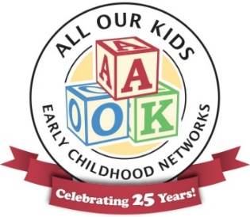

FY26 AOK Network Partners

- Adams County Health Department – WIC, Immunizations, Family Case Management, Lead, Healthworks
- Advocacy Network for Children
- Bella Ease
- Birth to Five Illinois: Region 1
- Blessing Health System
- CareNet Pregnancy Services
- Chaddock
- Cheerful Home Child Care & Early Learning Center
- Child and Family Connections #17
- Community for Christ Assistance Center (CFCAC)
- Covered Bottoms Diaper Bank (CBDB)
- DCFS – Quincy Field Office
- Horizons Social Services & KidsPacks
- John Wood Community College
- Liberty CUSD #2 Preschool
- Open Hands Food Pantry - Lutheran Church of St. John
- Parent and Child Together (PACT) for West Central Illinois
- Preferred Family Healthcare, Inc.
- Prevent Child Abuse Illinois
- Quanada
- Quincy Catholic Charities
- Quincy Children’s Museum & Ready Set Grow
- Quincy Family YMCA
- Quincy Medical Group – Behavioral Health
- Quincy Public Library
- Quincy Public Schools – Early Childhood and Family Center
- Quincy Public Schools – Nursing Department
- Quincy University
- Safe Kids Adams County
- SIU School of Medicine
- The Community Foundation
- Think First / Brain Trauma Awareness
- Transitions of Western IL – Parents as Teachers
- United Way of Adams County
- West Central Child Care Connection
- WSIU Public Broadcasting

